GIRLS’ UNIFORM REQUIREMENTS

FALL/SUMMER: 5th grade- 8th grade

NAVY, WHITE, AND KHAKI GLEN PLAID KILT NAVY & SHORT SLEEVE, BANDED-BOTTOM POLO (WITH LOGO)

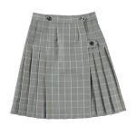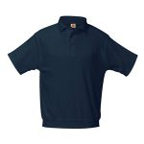
Navy, white, and khaki glen plaid kilt or khaki short with the navy golf shirt with the school logo. With the kilt, the students must wear navy knee highs or navy tights. With the shorts, the students must wear white socks that cover the ankles.
Your school uniform will always look neat with our tidy banded bottom polo shirt. Our polyester / cotton blend shirt is guaranteed NOT to shrink wash after wash.
Machine Wash Warm. Tumble Dry Low. Remove Promptly. Do not Iron Decoration.

KHAKI WALKING SHORTS* Optional in place of skirt
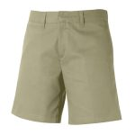
The updated styling of our Girl’s brushed twill flat front shorts will make your daughter want to wear her uniform. Sizes 7 and up are in a mid-rise, modern fit. Sizes 4-12, and all Plus size shorts come with an additional 2″ growth feature elastic in the shorts.
Machine Wash Warm. Do not Bleach. Tumble Dry Low. Remove Promptly. Cool Iron.

WINTER Uniform for 5th through 8th grade

NAVY, WHITE, AND KHAKI GLEN PLAID KILT WHITE, LONG SLEEVE, PETER PAN COLLAR BLOUSE 0r NAVY, LONG SLEEVE, BANDED-BOTTOM POLO (WITH LOGO)

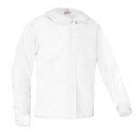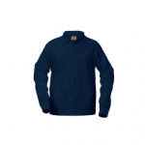
Navy, white and khaki glen plaid kilt. The students may choose to wear either the long sleeve navy golf shirt that has the school logo or a white oxford blouse with a navy blue V-neck sweater with the school logo. The students must wear navy knee highs or navy tights.

The classic “Peter Pan” school uniform blouse. Looks great with jumpers, shorts and pants.
Machine Wash Warm. Tumble Dry Medium. Remove Promptly. Use Warm Iron. Use Non-Chlorine Bleach when Needed.
Your school uniform will always look neat with our tidy banded bottom polo shirt. Our polyester / cotton blend shirt is guaranteed NOT to shrink wash after wash. The interlock knit shirt is also pill free!
Machine Wash Warm. Tumble Dry Low. Remove Promptly. Do not Iron Decoration.

NAVY, V-NECK PULLOVER SWEATER
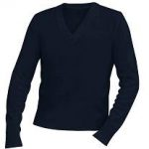
Our unisex pill free V-Neck Pullover sweater with reinforced elbows will last for many years. Without question the best uniform sweater on the market.
Machine Wash Warm. Turn Inside Out. Tumble Dry Low. No Bleach.

PHYSICAL EDUCATION UNIFORM REQUIREMENTS
Boys & Girls, Pre-Kindergarten Through Eighth Grade
